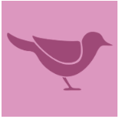
Wild Bird Fact File
Some interesting facts about the most common British Birds

1. House Sparrow
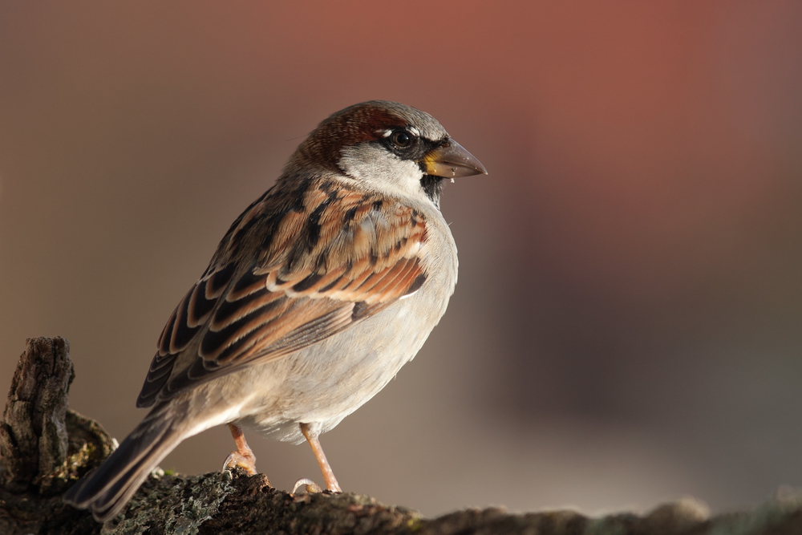

Latin Name: Passer domesticus
Description: These are the most familiar of all wild birds in the UK and they are common around the world. Noisy little plump brown-grey birds, they have short tails and stubby powerful beaks. They live in pairs and gather in large flocks.
Where: Sparrows are found in the rural countryside as well as towns and villages. They are less likely to be found in the centre of cities. They nest in holes and gaps in buildings, creepers and thick hedges.
When: All year round
Food: Sparrows are primarily seed-eaters although they are opportunistic eaters and will consume small insects and berries.
Population: 5,300,000 UK breeding pairs.
Population Trends: Recent data suggests that the population is in decline.
_________________________________________________________________________________

2. Starling

Latin Name: Sturnus vulgaris
Description: Starlings appear black but have a glossy purple and green sheen to their feathers. They have strong feet and are strong in flight. They are noisy and gregarious, spending much of the year in flocks. They also imitate a few sounds other than wild birds such as phones and cars!
Where: Widespread throughout the UK, especially in southern England. Huge roosts are found in plantations, reed beds and city centres.
When: All year round. Large numbers arrive in autumn to spend the winter here.
Food: They eat insects and fruit.
Population: 804,000 territories
Population Trends: Long-term monitoring by the British Trust for Ornithology (BTO) shows that starling numbers have fallen by 66 per cent in Britain since the mid-1970s.
___________________________________________________________________________________

3. Blackbird
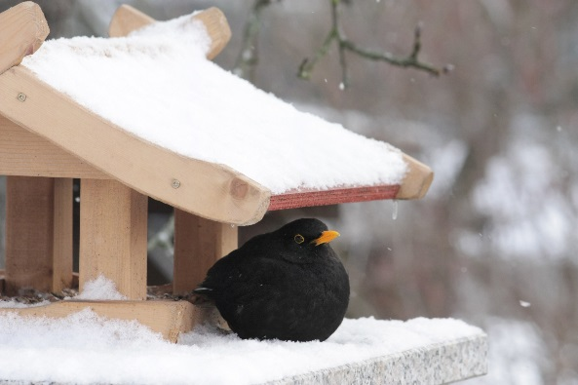

Latin Name: Turdus merula
Description: The male is all black with a yellow eye-ring and bill making it rather striking to look at. Strangely, the female is brown. One of the commonest UK birds, its song is lovely.
Where: Most commonly found in woods and gardens building neat, mud-lined nests. They reside in gardens and countryside and from coasts to hills, although not on the highest peaks.
When: All year round.
Food: It is omnivorous eating a wide range of insects, worms, fruit, seeds and berries.
Population: 5,100,000 pairs (breeding annually) and 10-15million birds present October – March.
Population Trends: The population trend for the blackbird shows a sustained period of decline from the 1970s to the mid-1990s, followed by a period of recovery, with a 26 per cent increase recorded by the Breeding Bird Survey between 1995 and 2008.

___________________________________________________________________________________

4. Bluetit
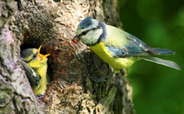

Latin Name: Cyanistes caeruleus
Description: A colourful mix of blue, yellow, white and green makes the blue tit one of our most attractive and most recognisable garden visitors. In winter, family flocks join up with other tits as they search for food. A garden with four or five blue tits at a feeder at any one time may be feeding 20 or more. They are clever feeders often hanging upside down when looking for food.
Where: Blue tits are common in woodland, hedgerows, parks and gardens. They're widespread and found across the whole of the UK with the exception of some Scottish islands.
When: All year round.
Food: Insects, caterpillars, spiders, seeds, nuts and other vegetable based food.
Population: 20-44 million pairs, 3,600,000 territories (breeding) and 15 million October – March

___________________________________________________________________________________

5. Woodpigeon
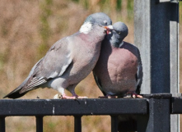

Latin Name: Columba palumbus
Description: This is the UK's largest and most common pigeon. It is grey with a pinkish breast and white patches on its neck and wings. It can be shy in the countryside but tame and approachable in towns and cities. Its cooing call is a familiar sound in woodlands as is the loud clatter of its wings when it flies away.
Where: Found across the UK in fields and woods, and also in town and city parks.
When: All year round
Food: Crops like cabbages, sprouts, peas and grain. Also buds, shoots, seeds, nuts and berries. They will also eat lavae, ants and small worms.
Population: 5,400,000 pairs
___________________________________________________________________________________

6. Chaffinch
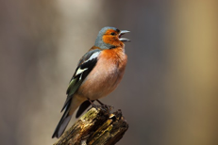

Latin Name: Fringilla coelebs
Description: The chaffinch is common and widespread in the UK. It is colourful and its patterned plumage helps it to blend in when feeding on the ground. In flight, the colour and white wing flash are more obvious. It prefers to hop about under the bird table or under the hedge rather than brave a bird feeder. Chaffinches have a loud and varied song.
Where: Around the UK in woodlands, hedgerows, fields, parks and gardens anywhere.
When: All year round.
Food: Insects and seeds.
Population: 6,200,000 territories

___________________________________________________________________________________

7. Robin
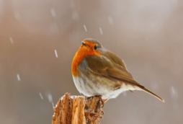

Latin Name: Erithacus rubecula
Description: The UK's favourite bird with its bright red breast. It is familiar throughout the year and especially at Christmas! Males and females look identical, and young birds have no red breast and are spotted with golden brown. Robins sing nearly all year round and despite their cute appearance, they are aggressively territorial and are quick to drive away intruders. They will sing at night next to street lights.
Where: Across the UK in woodland, hedgerows, parks and gardens.
When: All year round.
Food: Worms, seeds, fruits and insects.
Population: 6,700,000 territories
Population Trends: According to RSPB figures, robins have climbed three spaces and are now the 7th most commonly seen bird in the UK.
___________________________________________________________________________________

8. Great Tit
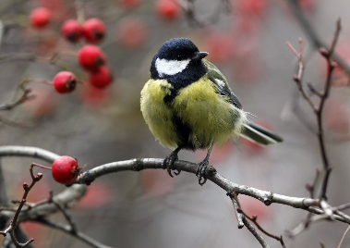

Latin Name: Parus major
Description: The largest UK tit, it is green and yellow with a striking black head and white cheeks. It can be quite aggressive at a bird table, fighting off smaller tits. In winter it joins with blue tits and others to form roaming flocks, which scour gardens and countryside for food.
Where: The Great Tit has adapted well to environment changes and is common in urban gardens and parks as well as woodlands in the countryside. Absent only from the Northern and Western Isles of Scotland.
When: All year round.
Food: In the summer it enjoys insects but throughout the winter months, has a more varied diet. They also eat seeds and nuts.
Population: 2,500,000 territorie

___________________________________________________________________________________

9. Goldfinch
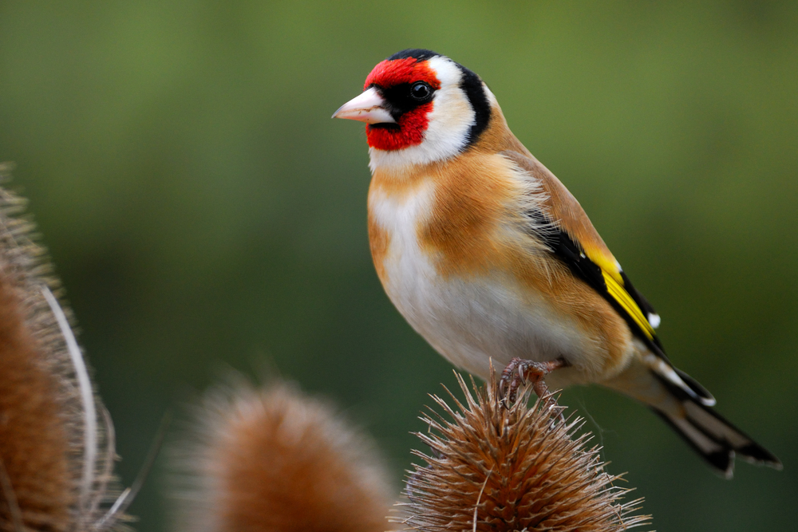

Latin Name: Carduelis carduelis
Description: A highly coloured finch with a bright red face and yellow wing patch. These are sociable birds often breeding in loose colonies. They also have a beautiful twittering song and call. Their long fine beaks allow them to extract otherwise inaccessible seeds from thistles and teasels. Increasingly they are visiting bird tables and feeders. In winter many UK goldfinches migrate as far south as Spain.
Where: They are found throughout the UK in bushes and trees and even in rougher ground. They like parks, gardens, heathland and commons. They are less common in upland areas and most numerous in southern England.
When: All year round.
Food: Seeds and insects in summer.
Population: 313,000 territories / 100,000 birds UK wintering
Population Trends:
___________________________________________________________________________________

10. Collared Dove
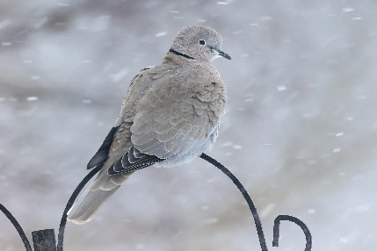

Latin Name: Streptopelia decaocto
Description: Collared doves are a pale, pinky-brown grey colour, with a distinctive black neck collar (as the name suggests). They have deep red eyes and reddish feet. Their cooing is a familiar sound. Although they are often alone or in pairs, flocks may form where there is a lot of food available.
Where: They are found throughout the UK but often in towns and villages. They're common visitors to gardens.
When: Any time of year.
Food: Seeds and grain.
Population: 990,000 pairs

___________________________________________________________________________________

